**3.4: Stress** **3**

**3.5: Cartesian Stress Components** **3**

**3.6 Mohr’s Circle for Plane Stress (one face is z=0)** **3**

**3.8: Elastic Strain** **4**

**3.10: Normal stresses for beams in bending** **4**

**3.12: Torsion** **5**

**3.13: Stress Concentration** **6**

**4.1: Spring Rates** **6**

**4.2: Tension, Compression, and Torsion** **6**

**4.3: Deflection Due to Bending** **6**

**4.5: Beam Deflection by Superposition** **6**

**4.7: Strain Energy** **6**

**4.8: Castilgliano’s Theorem** **7**

* Stress
  + Recognize when a stress state corresponds to plane stress
  + Identify all the stresses at a point from different loadings
    - Axial
    - Normal due to bending
    - Shear due to bending
      * Transverse shear
        + Neglected for long, (l/d>10) and/or thick members
    - Torsion
  + Draw a Mohr’s circle
* Torsion
  + Compute shear stresses due to torsion
* Critical stress point
  + The ability to compute relevant stresses at different points in a structure and determine what is the critical point in the element
* Compute spring constant
  + And stiffness for axial and torsion
* Obtain deflection of a beam
* Use superposition
* Castigliano’s theorem
  + To compute deflection of a point
  + Be able to compute maximum deflection/slope for any location
  + Problem 4-58 is a good example

# 3.4: Stress

* + We have normal stress and tangential shear stress

# 3.5: Cartesian Stress Components

* + 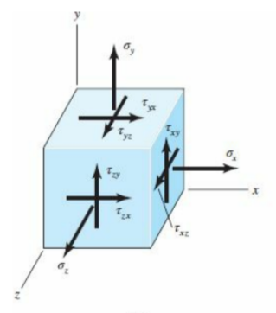
  + In order to keep equilibrium

$τ_{yx}=τ_{xy}$

$τ_{zy}=τ_{yz}$

$τ_{xz}=τ_{zx}$

# 3.6 Mohr’s Circle for Plane Stress (one face is )

* + Center $=\frac{σ_{x}+σ_{y}}{2}$
  + Radius $=\sqrt{(\frac{σ_{x}-σ_{y}}{2})^{2}+{τ_{xy}}^{2}}$
  + Principle stresses:
    - Max stress: $σ_{1}=$ Center + Radius
    - $σ_{2}=$ Center - Radius
    - $τ_{max}=$ Radius
  + $ϕ$ is a rotation of the element in the real world
    - $90^{o}$ rotation on mohr circle is $45^{o}$ in real world
    - $tan(2ϕ_{s})= -\frac{σ_{x}-σ_{y}}{2τ_{xy}}$ ${2ϕ}_{s}$ is rotation to get to max shear
    - $2ϕ_{s}-2⋅{45}^{o}$ is rotation to get to principal stress plane ${2ϕ}_{p}$
  + 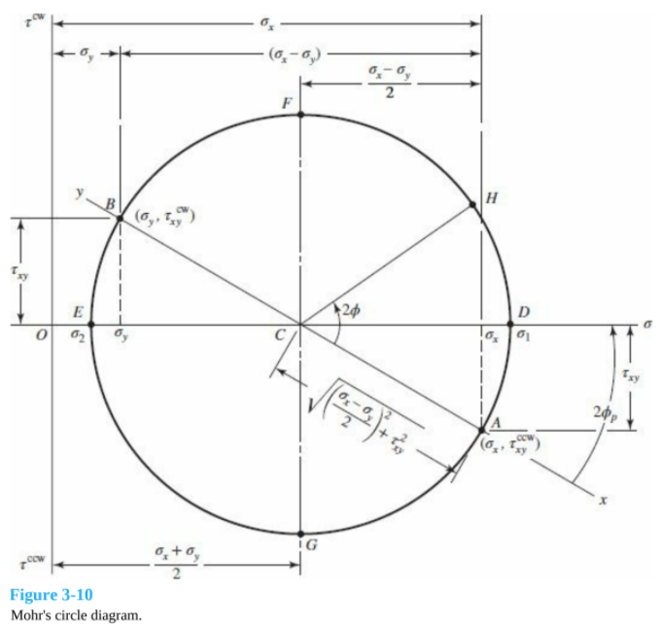

# 3.8: Elastic Strain

* + Hooke's Law
 $σ=Eϵ$

 $τ=Gγ$

+ Poisson’s ratio
 $ϵ_{x}=\frac{σ_{x}}{E}$

 $ϵ_{y}=ϵ_{z}= -ν\frac{σ_{x}}{E}$

  - * Negative because positive tension causes swishing in other axis
    - If stress in all three planes

$ϵ_{x}=\frac{1}{E}[σ_{x}-ν(σ_{y}+σ_{z})]$

$E=2G(1+ν)$

# 3.10: Normal stresses for beams in bending

* + 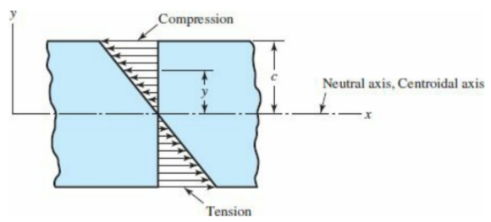
  + 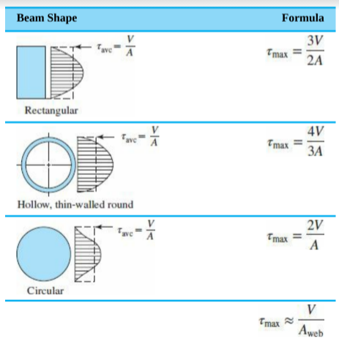
* Shear stresses for beams in bending
  + Transverse shear stress from the vertical shear force

 $τ=\frac{VQ}{Ib}$ $Q=\int_{y_{1}}^{c}{}ydA$

  - Max shear stress occurs along the neutral axis
    - For a rectangular cross section:
 $τ=\frac{V}{2I}(c^{2}-{y_{1}}^{2})$

   - Last one in the table is for thin-walled I beams
  + Remember to do a mohr’s circle to find true maxes based off of element rotation
    - $τ_{max}=\sqrt{{(\frac{σ}{2})}^{2}+τ}$ 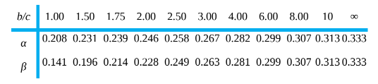

# 3.12: Torsion

* + Circular cross section
 $θ=\frac{Tl}{GJ}$ $τ_{max}=\frac{Tr}{J}$

+ Rectangular cross section ($b×c$), $b$ is longest side

$θ=\frac{Tl}{βαc^{3}G}$ $τ_{max}=\frac{T}{αbc^{2}}≈\frac{T}{bc^{2}}(3+\frac{1.8}{b/c})$

# 3.13: Stress Concentration

* + Max stress around a geometric discontinuity
 $K_{t}=\frac{σ_{max}}{σ_{o}}$

   - Table A-15

# 4.1: Spring Rates



$k=\frac{F}{y}$ $k=\frac{T}{θ}$

# 4.2: Tension, Compression, and Torsion

* + Solid round bar $J=\frac{πd^{4}}{32}$ $k=\frac{GJ}{l}$

# 4.3: Deflection Due to Bending

* + Curvature: $\frac{1}{ρ}=\frac{M}{EI}$
  + Deflection: $y=f(x)$
  + Slope at end: $θ=\frac{dy}{dx}$
  + Moment: $\frac{M}{EI}=\frac{d^{2}y}{dx^{2}}$
  + Shear: $\frac{V}{EI}=\frac{d^{3}y}{dx^{3}}$
  + Load: $\frac{q}{EI}=\frac{d^{4}y}{dx^{4}}$

# 4.5: Beam Deflection by Superposition

* + Table A-9 has simple loadings

# 4.7: Strain Energy

* + Tension and compression ($k=\frac{AE}{l}$)
 $U=\frac{F^{2}l}{2AE}$ $U=\int{}\frac{F^{2}}{2AE}dx$

+ Torsion ($k=\frac{GJ}{l}$)
 $U=\frac{T^{2}l}{2GJ}$ $U=\int{}\frac{T^{2}}{2GJ}dx$

+ Direct shear ($y=\frac{F}{AG}$)
 $U=\frac{F^{2}l}{2AG}$ $U=\int{}\frac{F^{2}}{2AG}dx$

+ 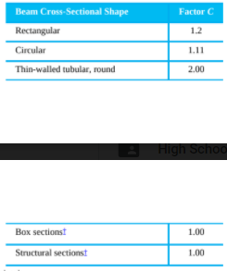Bending
 $U=\frac{M^{2}l}{2EI}$ $U=\int{}\frac{M^{2}}{2EI}dx$

+ Transverse Shear

$U=\frac{CV^{2}l}{2AG}$ $U=\int{}\frac{CV^{2}}{2AG}dx$

# 4.8: Castilgliano’s Theorem

* + - is in direction $i$ and at the point we want to know deflection $i$
  + Don’t forget chain rule with these partial derivatives
  + We already know under axial and torsion that
 $δ=\frac{Fl}{AE}$ $θ=\frac{Tl}{GJ}$

+ Tension and compression $U=\int{}\frac{F^{2}}{2AE}dx$
 $δ_{i}=\int{}\frac{1}{AE}(F\frac{∂F}{∂F_{i}})dx$

   - * If for example the force $F$ was a function of another force happening in multiple directions, you take the partial with our direction in question because of chain rule
  + Torsion $U=\int{}\frac{T^{2}}{2GJ}dx$
 $θ_{i}=\int{}\frac{1}{GJ}(T\frac{∂T}{∂M_{i}})dx$

 + Bending $U=\int{}\frac{M^{2}}{2EI}dx$
 $δ_{i}=\int{}\frac{1}{EI}(M\frac{∂M}{∂F_{i}})dx$

   - * So if $M=Fx$, Force times distance, then the partial derivative would be $x$